Machine Learning is a subfield of Artificial intelligence
"Learning machines to imitate human intelligence"

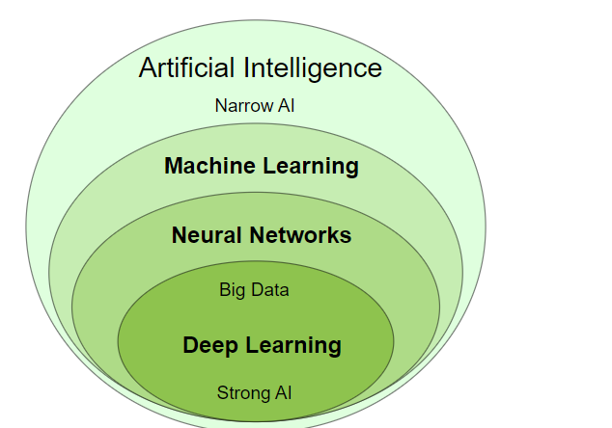

Machine Learning (ML)
Traditional programming uses known algorithms to produce results from data:
Data + Algorithms = Results
Machine learning creates new algorithms from data and results:
Data + Results = Algorithms

Neural Networks (NN)
Neural Networks is:
- A programming technique
- A method used in machine learning
- A software that learns from mistakes
Neural Networks are based on how the human brain works:
Neurons are sending messages to each other. While the neurons are trying to solve a problem (over and over again), it is strengthening the connections that lead to success and diminishing the connections that lead to failure.

Perceptrons
The Perceptron defines the first step into Neural Networks.
It represents a single neuron with only one input layer, and no hidden layers.

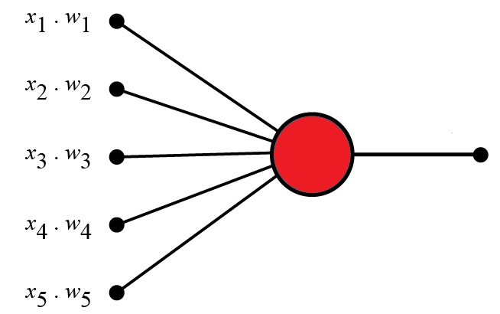

Neural Networks
Neural Networks are Multi-Layer Perceptrons.
In its simplest form, a neural network is made up from:
- An input layer (yellow)
- A hidden layer (blue)
- An output layer (red)
In the Neural Network Model, input data (yellow) are processed against a hidden layer (blue) before producing the final output (red).
The First Layer:
The yellow perceptrons are making simple decisions based on the input. Each single decision is sent to the perceptrons in the next layer.
The Second Layer:
The blue perceptrons are making decisions by weighing the results from the first layer. This layer make more complex decisions at a more abstract level than the first layer.

Deep Neural Networks
Deep Neural Networks is:
- A programming technique
- A method used in machine learning
- A software that learns from mistakes
Deep Neural Networks are made up of several hidden layers of neural networks that perform complex operations on massive amounts of data.
Each successive layer uses the preceding layer as input.
For instance, optical reading uses low layers to identify edges, and higher layers to identify letters.

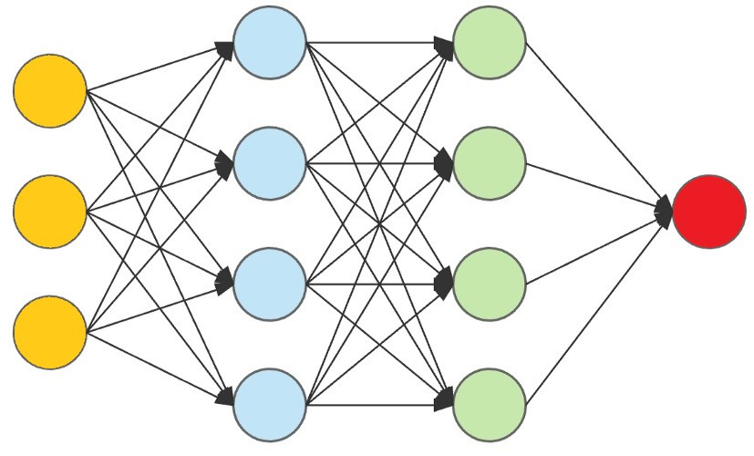
In the Deep Neural Network Model, input data (yellow) are processed against a hidden layer (blue) and modified against more hidden layers (green) to produce the final output (red).
The First Layer:
The yellow perceptrons are making simple decisions based on the input. Each single decision is sent to the perceptrons in the next layer.
The Second Layer:
The blue perceptrons are making decisions by weighing the results from the first layer. This layer make more complex decisions at a more abstract level than the first layer.
The Third Layer:
Even more complex decisions are made by the green perceptrons.

Deep Learning (DL)
Deep Learning is a subset of Machine Learning.
Deep Learning is responsible for the AI boom of the last years.
Deep learning is an advanced type of ML that handles complex tasks like image recognition.

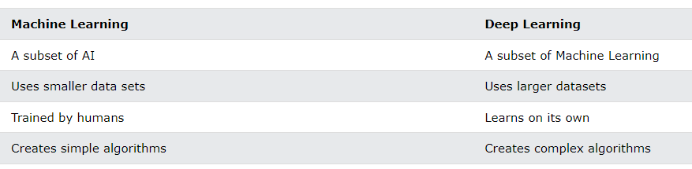

What is Artificial Intelligence?
Artificial Intelligence suggest that machines can mimic humans in:
- Talking
- Thinking
- Learning
- Planning
- Understanding
Artificial Intelligence is also called Machine Intelligence and Computer Intelligence.

Arthur Samuel 1959:
"Machine Learning is a subfield of computer science that gives computers the ability to learn without being programmed"
Arthur Samuel, IBM Journal of Research and Development, Vol. 3, 1959.

Wikipedia 2022:
Artificial intelligence is intelligence demonstrated by machines. Unlike natural intelligence displayed by humans and animals, which involves consciousness and emotionality.

Investopedia 2022:
Artificial intelligence refers to the simulation of human intelligence in machines that are programmed to think like humans and mimic their actions.

IBM 2022:
Artificial intelligence leverages computers and machines to mimic the problem-solving and decision-making capabilities of the human mind.

Britannica 2022:
Artificial intelligence is the ability of a digital computer or computer-controlled robot to perform tasks commonly associated with intelligent beings, .... such as the ability to reason, discover meaning, generalize, or learn from past experience.

Artificial Intelligence (AI)
Artificial Intelligence is a scientific discipline embracing several Data Science fields ranging from narrow AI to strong AI, including machine learning, deep learning, big data and data mining.

Narrow AI
Narrow Artificial Intelligence is limited to narrow (specific) areas like most of the AI we have around us today:
- Email spam Filters
- Text to Speech
- Speech Recognition
- Self Driving Cars
- E-Payment
- Google Maps
- Text Autocorrect
- Automated Translation
- Chatbots
- Social Media
- Face Detection
- Visual Perception
- Search Algorithms
- Robots
- Automated Investment
- NLP - Natural Language Processing
- Flying Drones
- IBM's Dr. Watson
- Apple's Siri
- Microsoft's Cortana
- Amazon's Alexa
- Netflix's Recommendations
Narrow AI is also called Weak AI.
Weak AI: Built to simulate human intelligence.
Strong AI: Built to copy human intelligence.

Strong AI
Strong Artificial Intelligence is the type of AI that mimics human intelligence.
Strong AI indicates the ability to think, plan, learn, and communicate.
Strong AI is the theoretical next level of AI: True Intelligence.
Strong AI moves towards machines with self-awareness, consciousness, and objective thoughts.
✔ One need not decide if a machine can "think".
One need only decide if a machine can act as intelligently as a human.
Alan Turing

Machine Learning in JavaScript
Traditionally, Machine Learning applications are using R or Python.
But JavaScript has a great future as an Machine Learning language:
- JavaScript is well known. All developers can use it.
- Security is built in. JavaScript cannot access your files.
- JavaScript is faster than Python.
- JavaScript can use hardware acceleration.
- JavaScript runs in the browser

JavaScript is Good for Machine Learning
Machine Learning can be math-heavy. The nature of neural networks is highly technical, and the jargon that goes along with it tends to scare people away.
This is where JavaScript comes to help, with easy to understand software to simplifying the process of creating and training neural networks.
With new Machine Learning libraries, JavaScript developers can add Machine Learning and Artificial Intelligence to web applications.

WebGL API
WebGL is a JavaScript API for rendering 2d and 3D graphics in any browser.
WebGL can run on both integrated and standalone graphic cards in any PC.
WebGL brings 3D graphics to the web browser. Major browser vendors Apple (Safari), Google (Chrome), Microsoft (Edge), and Mozilla (Firefox) are members of the WebGL Working Group.

JavaScript Machine Learning Libraries
Machine Learning in the Browser means:
- Machine Learning in JavaScript
- Machine Learning for the Web
- Machine Learning for Everyone
- Machine Learning on more Platforms

Advantages:
- Easy to use. Nothing to install.
- Powerful graphics. Browsers support WebGL.
- Better privacy. Data can stay on the client.
- More platforms. JavaScript runs on mobile devices.

Math.js
Math.js is an extensive math library for JavaScript and Node.js.
Math.js is powerful and easy to use. It comes with a large set of built-in functions, a flexible expression parser, and solutions to work with many data types like numbers, big numbers, complex numbers, fractions, units, arrays, and matrices.

Brain.js
Brain.js is a JavaScript library that makes it easy to understand Neural Networks because it hides the complexity of the mathematics.
Brain.js is simple to use. You do not need to know neural networks in details to work with Brain.js.
Brain.js provides multiple neural network implementations as different neural nets can be trained to do different things well.
Learn More ...

ml5.js
ml5.js is trying to make machine learning more accessible to a wider audience.
The ml5 team is working to wrap machine learning functionality in friendlier ways.
The example below uses only three lines of code to classify an image:
<img id="image" src="pic1.jpg" width="100%">
<script>
const classifier = ml5.imageClassifier('MobileNet');
classifier.classify(document.getElementById("image"), gotResult);
function gotResult(error, results) { ... }
</script>

<!DOCTYPE html>

<html>

<script src="https://cdnjs.cloudflare.com/ajax/libs/p5.js/1.0.0/p5.min.js"></script>

<script src="https://unpkg.com/ml5@latest/dist/ml5.min.js"></script>

<body>

<h1>Image Classification</h1>

<h2>With MobileNet and ml5.js</h2>

<div id="result">Scanning ...</div>

<img id="image" src="pic1.jpg" width="100%">

<script>

// Initialize Image Classifier with MobileNet.

const classifier = ml5.imageClassifier('MobileNet');

classifier.classify(document.getElementById("image"), gotResult);

// Function to run when results arrive

function gotResult(error, results) {

const element = document.getElementById("result");

if (error) {

element.innerHTML = error;

} else {

let num = results[0].confidence * 100;

element.innerHTML = results[0].label + "<br>Confidence: " + num.toFixed(2) + "%";

}

}

</script>

</body>

</html>

Image Classification

With MobileNet and ml5.js
robin, American robin, Turdus migratorius
Confidence: 92.93%


Try substitute "pic1.jpg" with "pic2.jpg" and "pic3.jpg".

TensorFlow
TensorFlow Playground is a web application written in d3.js.
With TensorFlow Playground you can learn about Neural Networks (NN) without math.
In your own Web Browser you can create a Neural Network and see the result.
TensorFlow.js was previously called Tf.js and Deeplearn.js.

Plotting in the Browser
Here is a list of some JavaScript libraries to use for both Machine Learning graphs and other HTML charts:
- Plotly.js
- Chart.js
- D3.js
- Google Chart

Plotting Equations
Enter Equation:
01234567891516171819

Scatter
Try substitute "pic1.jpg" with "pic2.jpg" and "pic3.jpg".

TensorFlow
TensorFlow Playground is a web application written in d3.js.
With TensorFlow Playground you can learn about Neural Networks (NN) without math.
In your own Web Browser you can create a Neural Network and see the result.
TensorFlow.js was previously called Tf.js and Deeplearn.js.

Plotting in the Browser
Here is a list of some JavaScript libraries to use for both Machine Learning graphs and other HTML charts:
- Plotly.js
- Chart.js
- D3.js
- Google Chart

Plotting Equations
Enter Equation:
01234567891516171819
4.615.01262

Scatter

<!DOCTYPE html>

<html>

<script src="https://cdn.plot.ly/plotly-latest.min.js"></script>

<body>

<h1>Using Plotly.js</h1>

<p>Enter Equation:</p>

<p><input id="equation" type="text" value="x * 2 + 17"></p>

<p>

<button onclick='plot("scatter")'>Scatter</button>

<button onclick='plot("lines")'>Draw Line</button>

</p>

<div id="myPlot" style="width:100%;max-width:700px"></div>

<script>

function plot(type) {

const exp = document.getElementById("equation").value;

const xValues = [];

const yValues = [];

let mode = "lines";

if (type == "scatter") {mode = "markers"}

// Generate values

for (let x = 0; x <= 10; x += 1) {

xValues.push(x);

yValues.push(eval(exp));

}

// Display using Plotly

const data = [{x:xValues, y:yValues, mode:mode, type:"scatter"}];

const layout = {title: "y = " + exp};

Plotly.newPlot("myPlot", data, layout);

}

</script>

</body>

</html>

Using Plotly.js
Enter Equation:
Scatter Draw Line

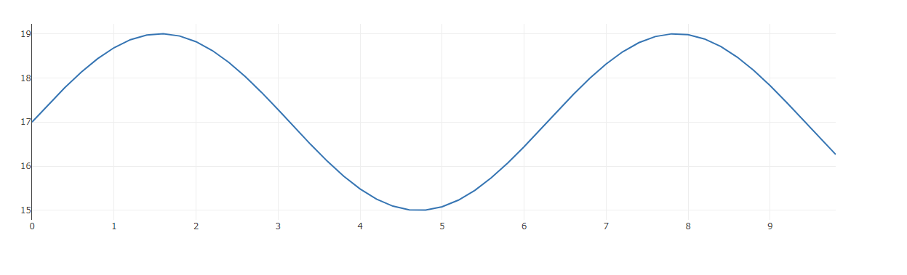

Plotting Values
Enter X and Y Values:
60801001201408101214

Scatter

<!DOCTYPE html>

<html>

<script src="https://cdn.plot.ly/plotly-latest.min.js"></script>

<body>

<h1>Using Plotly.js</h1>

<p>X values:<br>

<input id="xvalues" style="width:95%" type="text"

value="50,60,70,80,90,100,110,120,130,140,150"></p>

<p>Y values:<br>

<input id="yvalues" style="width:95%" type="text"

value="7,8,8,9,9,9,10,11,14,14,15"></p>

<button onclick='plot("scatter")'>Scatter</button>

<button onclick='plot("lines")'>Draw Lines</button>

<div id="myPlot" style="width:100%;max-width:700px"></div>

<script>

function plot(type) {

const xArray = document.getElementById("xvalues").value.split(',');

const yArray = document.getElementById("yvalues").value.split(',');

let mode = "lines";

if (type == "scatter") {mode = "markers"}

Plotly.newPlot("myPlot", [{x:xArray, y:yArray, mode:mode, type:"scatter"}]);

}

</script>

</body>

</html>

Using Plotly.js
X values:
Y values:

Scatter Draw Lines

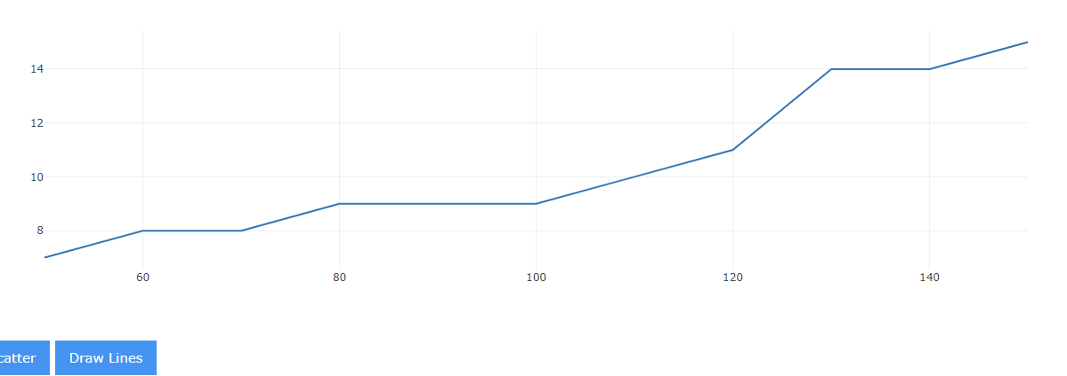

Machine Learning Languages
Programming languages involved in Machine Learning and Artificial Intelligence are:
- LISP
- R
- Python
- C++
- Java
- JavaScript
- SQL

LISP
LISP is the second oldest programming language in the world (1958), one year younger than Fortran (1957).
The term Artificial Intelligence was made up by John McCarthy who invented LISP.
LISP was founded on the theory of Recursive Functions (self modifying functions), and this is very suitable for Machine Learning programs where "self-learning" is an important part of the program.

The R Language
R is a programming language for Graphics and Statistical computing.
R is supported by the R Foundation for Statistical Computing.
R comes with a wide set of statistical and graphical techniques for:
- Linear Modeling
- Nonlinear Modeling
- Statistical Tests
- Time-series Analysis
- Classification
- Clustering

Python
Python is a general-purpose coding language. It can be used for all types of programming and software development.
Python is typically used for server development, like building web apps for web servers.
Python is also typically used in Data Science.
An advantage for using Python is that it comes with some very suitable libraries:
- NumPy (Library for working with Arrays)
- SciPy (Library for Statistical Science)
- Matplotlib (Graph Plotting Library)
- NLTK (Natural Language Toolkit)
- TensorFlow (Machine Learning)

C++
C++ holds the title: "The worlds fastest programming language".
Because of the speed, C++ is a preferred language when programming Computer Games.
It provides faster execution and has less response time which is applied in search engines and development of computer games.
Google uses C++ in Artificial Intelligence and Machine Learning programs for SEO (Search Engine Optimization).
SHARK is a super-fast C++ library with support for supervised learning algorithms, linear regression, neural networks, and clustering.
MLPACK is also a super-fast machine learning library for C++.

Java
Java is another general-purpose coding language that can be used for all types of software development.
For Machine Learning, Java is mostly used to create algorithms, and neural networks.

SQL
SQL (Structured Query Language) is the most popular language for managing data.
Knowledge of SQL databases, tables and queries helps data scientists when dealing with data.
SQL is very convenient for storing, manipulating, and retrieving data in databases.

Artificial Music Intelligence
Can an algorithm compose better music than a human?
David Cope is a former professor of music at the University of Santa Cruz (California).
For over 30 years, David Cope has been developing Emmy or EMI (Experimental Musical Intelligence), an algorithm to compose music in the style of famous composers.

Bach, Larson, or EMI?
In a test performed by professor Douglas Hofstadter of the University of Oregon, a pianist performed three musical pieces in the style of Bach:
- One written by Bach
- One written by Steve Larson
- One written by EMI
Dr. Larson was hurt when the audience concluded that his piece was written by EMI.
He felt better when the listeners decided that the piece composed by EMI was a genuine Bach.
Source: New York Times

Project Baseline
Project Baseline is an initiative to make it easy for everyone to contribute to the map of human health and to participate in clinical research.
In Project Baseline, researchers, clinicians, engineers, designers, advocates, and volunteers, can collaborate building the next generation of healthcare tools and services.

Data Scientists
Data Scientists can be experts in multiple disciplines:
- Applied mathematics
- Computational statistics
- Computer Science
- Machine learning
- Deep learning
Data Scientists also have significant big data experience:
- Business Intelligence
- Data Base Design
- Data Warehouse Design
- Data Mining
- SQL Queries
- SQL Reporting

Artificial Health Intelligence
The Corona Pandemic pushed the need for optimizing Medical Healthcare.
Machine learning is a new technology that can provide better drug discovery, shorter development time, and lower drug costs.
Machine Learning enables healthcare to use "big data" for making better medical or clinical decisions.

FDA Statement
Statement from FDA Commissioner Scott Gottlieb, M.D. on steps toward a new, tailored review framework for artificial intelligence-based medical devices:
"Artificial intelligence and machine learning have the potential to fundamentally transform the delivery of health care. As technology and science advance, we can expect to see earlier disease detection, more accurate diagnosis, more targeted therapies and significant improvements in personalized medicine".

Linear Graphs
Machine Learning often uses line graphs to show relationships.
A line graph displays the values of a linear function: y = ax + b
Important keywords:
- Linear (Straight)
- Slope (Angle)
- Intercept (Start value)

Linear
Linear means straight. A linear graph is a straight line.
The graph consists of two axes: x-axis (horizontal) and y-axis (vertical).

<!DOCTYPE html>

<html>

<script src="https://cdn.plot.ly/plotly-latest.min.js"></script>

<body>

<div id="myPlot" style="width:100%;max-width:700px"></div>

<script>

const xValues = [];

const yValues = [];

// Generate values

for (let x = 0; x <= 10; x += 1) {

xValues.push(x);

yValues.push(x);

}

// Define Data

const data = [{

x: xValues,

y: yValues,

mode: "lines"

}];

// Define Layout

const layout = {title: "y = x"};

// Display using Plotly

Plotly.newPlot("myPlot", data, layout);

</script>

</body>

</html>

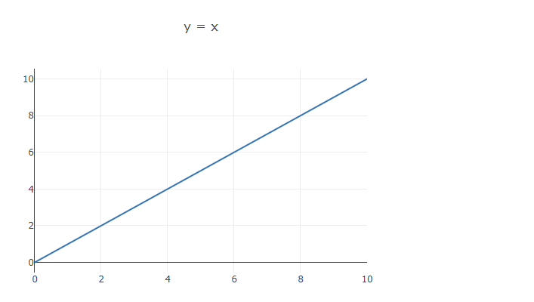

Example
const xValues = [];
const yValues = [];
// Generate values
for (let x = 0; x <= 10; x += 1) {
xValues.push(x);
yValues.push(x);
}
// Define Data
const data = [{
x: xValues,
y: yValues,
mode: "lines"
}];
// Define Layout
const layout = {title: "y = x"};
// Display using Plotly
Plotly.newPlot("myPlot", data, layout);

Slope
The slope is the angle of the graph.
The slope is the a value in a linear graph:
y = ax
In this example, slope = 1.2:

Example
let slope = 1.2;
const xValues = [];
const yValues = [];
// Generate values
for (let x = 0; x <= 10; x += 1) {
xValues.push(x);
yValues.push(x * slope);
}
// Define Data
const data = [{
x: xValues,
y: yValues,
mode: "lines"
}];
// Define Layout
const layout = {title: "Slope=" + slope};
// Display using Plotly
Plotly.newPlot("myPlot", data, layout);
Try it Yourself »

<!DOCTYPE html>

<html>

<script src="https://cdn.plot.ly/plotly-latest.min.js"></script>

<body>

<div id="myPlot" style="width:100%;max-width:700px"></div>

<script>

let slope = 1.2;

const xValues = [];

const yValues = [];

// Generate values

for (let x = 0; x <= 10; x += 1) {

xValues.push(x);

yValues.push(x * slope);

}

// Define Data

const data = [{

x: xValues,

y: yValues,

mode: "lines"

}];

//Define Layout

const layout = {title: "Slope=" + slope};

// Display using Plotly

Plotly.newPlot("myPlot", data, layout);

</script>

</body>

</html>

Intercept
The Intercept is the start value of the graph.
The intercept is the b value in a linear graph:
y = ax + b
In this example, slope = 1.2 and intercept = 2:

Example
let slope = 1.2;
let intercept = 7;
const xValues = [];
const yValues = [];
// Generate values
for (let x = 0; x <= 10; x += 1) {
xValues.push(x);
yValues.push(x * slope + intercept);
}
// Define Data
const data = [{
x: xValues,
y: yValues,
mode: "lines"
}];
// Define Layout
const layout = {title: "Slope=" + slope + " Intercept=" + intercept};
// Display using Plotly
Plotly.newPlot("myPlot", data, layout);

<!DOCTYPE html>

<html>

<script src="https://cdn.plot.ly/plotly-latest.min.js"></script>

<body>

<div id="myPlot" style="width:100%;max-width:700px"></div>

<script>

let slope = 1.2;

let intercept = 7;

const xValues = [];

const yValues = [];

// Generate values

for (let x = 0; x <= 10; x += 1) {

xValues.push(x);

yValues.push(x * slope + intercept);

}

// Define Data

const data = [{

x: xValues,

y: yValues,

mode: "lines"

}];

// Define Layout

let layout = {title: "Slope=" + slope + " Intercept=" + intercept};

// Display using Plotly

Plotly.newPlot("myPlot", data, layout);

</script>

</body>

</html>

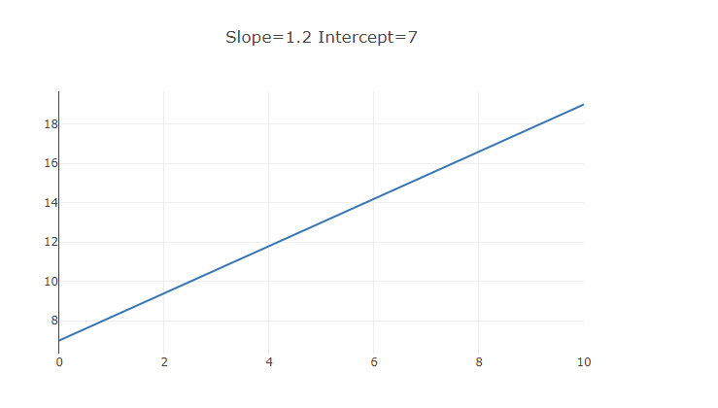

Scatter Plots
- Data Collections
- Scatter Plots
- Graphs

Data Collection
Collecting data is the most important part of any Machine Intelligence projects.
The most common data to collect are numbers and measurements.
Often data are stored in arrays representing the relationship between values.
This table contains house prices versus size:

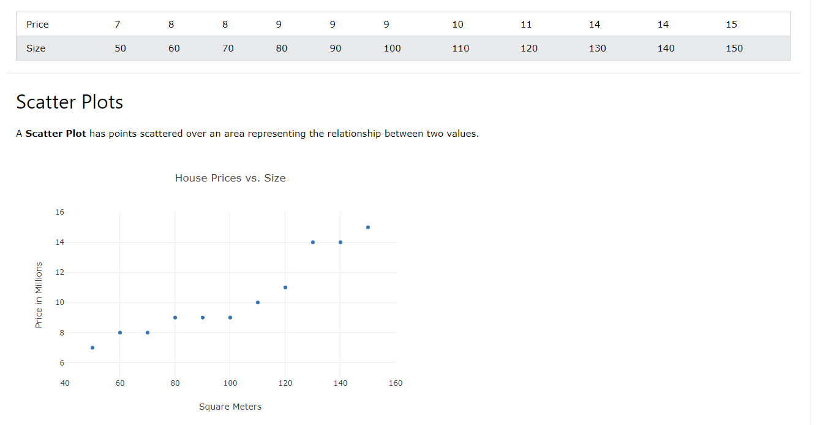

Example
const xArray = [50,60,70,80,90,100,110,120,130,140,150];
const yArray = [7,8,8,9,9,9,10,11,14,14,15];
// Define Data
const data = [{
x: xArray,
y: yArray,
mode:"markers"
}];
// Define Layout
const layout = {
xaxis: {range: [40, 160], title: "Square Meters"},
yaxis: {range: [5, 16], title: "Price in Millions"},
title: "House Prices vs. Size"
};
// Display with Plotly
Plotly.newPlot("myPlot", data, layout);

<!DOCTYPE html>

<html>

<script src="https://cdn.plot.ly/plotly-latest.min.js"></script>

<body>

<div id="myPlot" style="width:100%;max-width:700px"></div>

<script>

const xArray = [50,60,70,80,90,100,110,120,130,140,150];

const yArray = [7,8,8,9,9,9,10,11,14,14,15];

// Define Data

const data = [{

x:xArray,

y:yArray,

mode:"markers"

}];

// Define Layout

const layout = {

xaxis: {range: [40, 160], title: "Square Meters"},

yaxis: {range: [5, 16], title: "Price in Millions"},

title: "House Prices vs. Size"

};

// Display using Plotly

Plotly.newPlot("myPlot", data, layout);

</script>

</body>

</html>

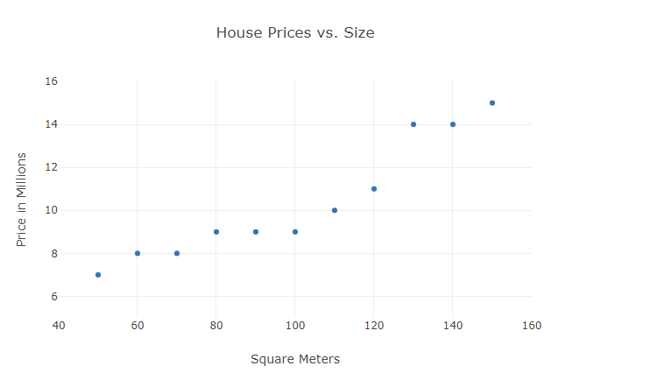

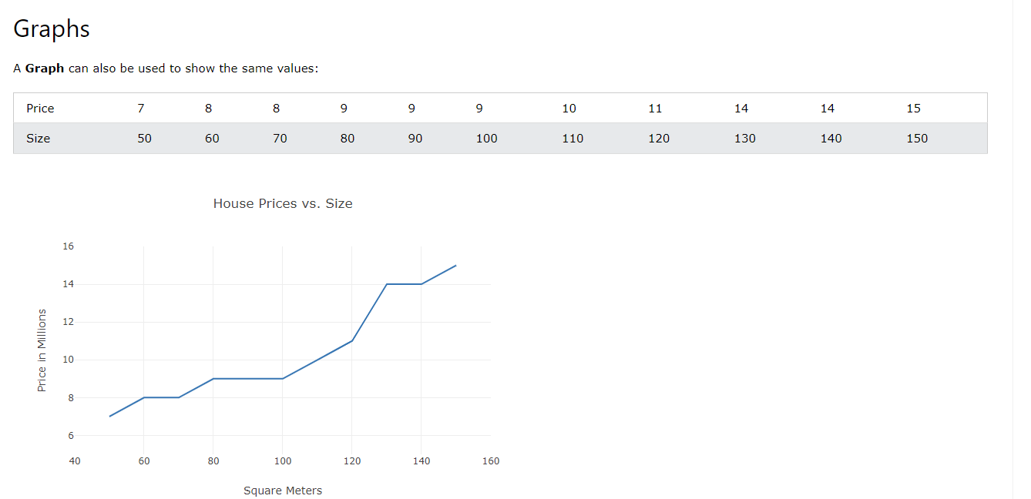

Source Code
const xArray = [50,60,70,80,90,100,110,120,130,140,150];
const yArray = [7,8,8,9,9,9,10,11,14,14,15];
// Define Data
const data = [{
x: xArray,
y:yArray,
mode:"lines"
}];
// Define Layout
const layout = {
xaxis: {range: [40, 160], title: "Square Meters"},
yaxis: {range: [5, 16], title: "Price in Millions"},
title: "House Prices vs Size"
};
// Display with Plotly
Plotly.newPlot("myPlot", data, layout);

<!DOCTYPE html>

<html>

<script src="https://cdn.plot.ly/plotly-latest.min.js"></script>

<body>

<div id="myPlot" style="width:100%;max-width:700px"></div>

<script>

const xArray = [50,60,70,80,90,100,110,120,130,140,150];

const yArray = [7,8,8,9,9,9,10,11,14,14,15];

// Define Data

const data = [{

x: xArray,

y: yArray,

mode:"lines"

}];

// Define Layout

const layout = {

xaxis: {range: [40, 160], title: "Square Meters"},

yaxis: {range: [5, 16], title: "Price in Millions"},

title: "House Prices vs. Size"

};

// Display using Plotly

Plotly.newPlot("myPlot", data, layout);

</script>

</body>

</html>

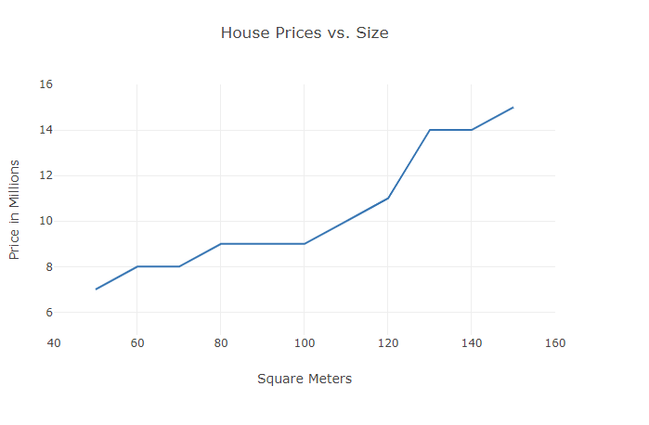

When to Use Scatter Plots
Scatter plots are great for:
- Seeing the "Big Picture"
- Compare different values
- Discovering potential trends
- Discovering patterns in data
- Discovering relationships between data
- Discovering Clusters and Correlations
- A Perceptron is an Artificial Neuron
- It is the simplest possible Neural Network
- Neural Networks are the building blocks of Machine Learning.

Frank Rosenblatt
- Frank Rosenblatt (1928 – 1971) was an American psychologist notable in the field of Artificial Intelligence.
- In 1957 he started something really big. He "invented" a Perceptron program, on an IBM 704 computer at Cornell Aeronautical Laboratory.
- Scientists had discovered that brain cells (Neurons) receive input from our senses by electrical signals.
- The Neurons, then again, use electrical signals to store information, and to make decisions based on previous input.
- Frank had the idea that Perceptrons could simulate brain principles, with the ability to learn and make decisions.

The Perceptron
- The original Perceptron was designed to take a number of binary inputs, and produce one binary output (0 or 1).
- The idea was to use different weights to represent the importance of each input, and that the sum of the values should be greater than a threshold value before making a decision like yes or no (true or false) (0 or 1).



Perceptron Example
Imagine a perceptron (in your brain).
The perceptron tries to decide if you should go to a concert.
Is the artist good? Is the weather good?
What weights should these facts have?

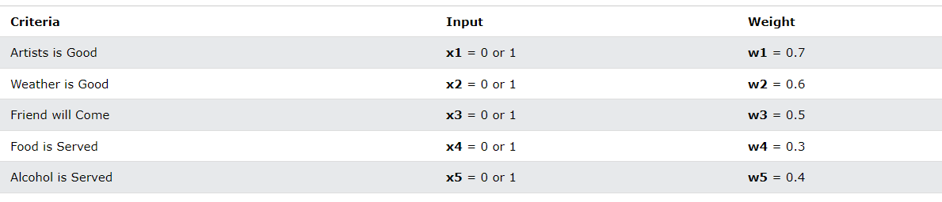

The Perceptron Algorithm
Frank Rosenblatt suggested this algorithm:
- Set a threshold value
- Multiply all inputs with its weights
- Sum all the results
- Activate the output
1. Set a threshold value:
- Threshold = 1.5
2. Multiply all inputs with its weights:
- x1 * w1 = 1 * 0.7 = 0.7
- x2 * w2 = 0 * 0.6 = 0
- x3 * w3 = 1 * 0.5 = 0.5
- x4 * w4 = 0 * 0.3 = 0
- x5 * w5 = 1 * 0.4 = 0.4
3. Sum all the results:
- 0.7 + 0 + 0.5 + 0 + 0.4 = 1.6 (The Weighted Sum)
4. Activate the Output:
- Return true if the sum > 1.5 ("Yes I will go to the Concert")

Note
If the weather weight is 0.6 for you, it might be different for someone else. A higher weight means that the weather is more important to them.
If the threshold value is 1.5 for you, it might be different for someone else. A lower threshold means they are more wanting to go to any concert.

Example
const threshold = 1.5;
const inputs = [1, 0, 1, 0, 1];
const weights = [0.7, 0.6, 0.5, 0.3, 0.4];
let sum = 0;
for (let i = 0; i < inputs.length; i++) {
sum += inputs[i] * weights[i];
}
const activate = (sum > 1.5);

<!DOCTYPE html>

<html>

<body>

<h1>JavaScript Perceptron</h1>

<p>Will I go to the consert?</p>

<div id="demo"></div>

<script>

const threshold = 1.5;

const inputs = [1, 0, 1, 0, 1];

const weights = [0.7, 0.6, 0.5, 0.3, 0.4];

let sum = 0;

for (let i = 0; i < inputs.length; i++) {

sum += inputs[i] * weights[i];

}

document.getElementById("demo").innerHTML = (sum > threshold);

</script>

</body>

</html>

JavaScript Perceptron
Will I go to the consert?
true

Perceptron Terminology
- Perceptron Inputs (nodes)
- Node values (1, 0, 1, 0, 1)
- Node Weights (0.7, 0.6, 0.5, 0.3, 0.4)
- Activation Function (sum > treshold)

Nodes (Perceptron Inputs)
Perceptron inputs are called nodes.
The nodes have both a value and a weight.

Node Values (Input Values)
Each input node has a binary value of 1 or 0.
This can be interpreted as true or false / yes or no.
In the example above, the node values are: 1, 0, 1, 0, 1

Node Weights
Weights shows the strength of each node.
In the example above, the node weights are: 0.7, 0.6, 0.5, 0.3, 0.4

The Activation Function
The activation function maps the the weighted sum into a binary value of 1 or 0.
This can be interpreted as true or false / yes or no.
In the example above, the activation function is simple: (sum > 1.5)

Note
It is obvious that a decision is NOT made by one neuron alone.
Many other neurons must provide input:
- Is the artist good
- Is the weather good
- ...
Multi-Layer Perceptrons can be used for very sophisticated decision making.

Neural Networks
The Perceptron defines the first step into Neural Networks:



Pattern Recognition
Neural Networks are used in applications like Facial Recognition.
These applications use Pattern Recognition.
This type of Classification can be done with a Perceptron.
Perceptrons can be used to classify data into two parts.
Perceptrons are also known as a Linear Binary Classifiers.

Pattern Classification
Imagine a strait line (a linear graph) in a space with scattered x y points.
How can you classify the points over and under the line?

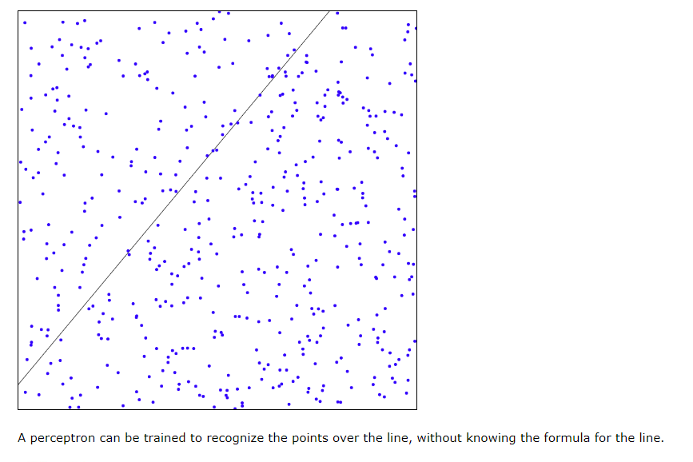

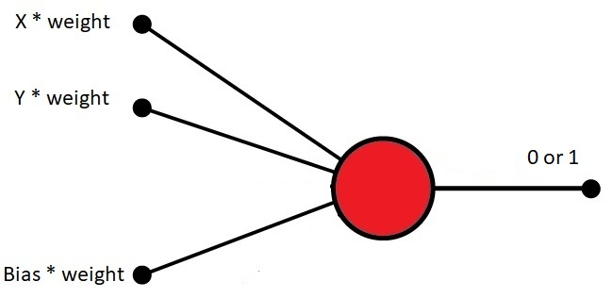

How to Program a Perceptron
To program a perceptron, we can use a simple JavaScript program that will:
- Create a simple plotter
- Create 500 random x y points
- Display the x y points
- Create a line function: f(x)
- Display the line
- Compute the desired answers
- Display the desired answers

Create a Simple Plotter
Creating a simple plotter object is described in the AI Canvas Chapter.

Example
const plotter = new XYPlotter("myCanvas");
plotter.transformXY();
const xMax = plotter.xMax;
const yMax = plotter.yMax;
const xMin = plotter.xMin;
const yMin = plotter.yMin;

Create Random X Y Points
Create as many xy points as wanted.
Let the x values be random (between 0 and maximum).
Let the y values be random (between 0 and maximum).
Display the points in the plotter:

Example
const numPoints = 500;
const xPoints = [];
const yPoints = [];
for (let i = 0; i < numPoints; i++) {
xPoints[i] = Math.random() * xMax;
yPoints[i] = Math.random() * yMax;
}
Try it Yourself »

<!DOCTYPE html>

<html>

<script src="myplotlib.js"></script>

<body>

<canvas id="myCanvas" width="400px" height="400px" style="width:100%;max-width:400px;border:1px solid black"></canvas>

<script>

// Create a Plotter

const plotter = new XYPlotter("myCanvas");

plotter.transformXY();

const xMax = plotter.xMax;

const yMax = plotter.yMax;

const xMin = plotter.xMin;

const yMin = plotter.yMin;

// Create Random XY Points

const numPoints = 500;

const xPoints = [];

const yPoints = [];

for (let i = 0; i < numPoints; i++) {

xPoints[i] = Math.random() * xMax;

yPoints[i] = Math.random() * yMax;

}

//Plot the Points

plotter.plotPoints(numPoints, xPoints, yPoints, "blue");

</script>

</body>

</html>

<!DOCTYPE html>

<html>

<script src="myplotlib.js"></script>

<body>

<canvas id="myCanvas" width="400px" height="400px" style="width:100%;max-width:400px;border:1px solid black"></canvas>

<script>

// Create a Plotter

const plotter = new XYPlotter("myCanvas");

plotter.transformXY();

const xMax = plotter.xMax;

const yMax = plotter.yMax;

const xMin = plotter.xMin;

const yMin = plotter.yMin;

// Create Random XY Points

const numPoints = 500;

const xPoints = [];

const yPoints = [];

for (let i = 0; i < numPoints; i++) {

xPoints[i] = Math.random() * xMax;

yPoints[i] = Math.random() * yMax;

}

//Plot the Points

plotter.plotPoints(numPoints, xPoints, yPoints, "blue");

</script>

</body>

</html>

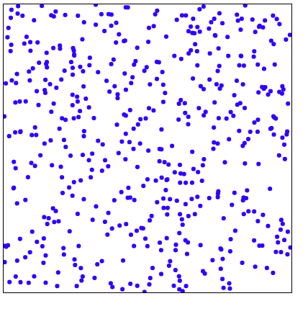

Create a Line Function
Display the line in the plotter:

Example
function f(x) {
return x * 1.2 + 50;
}

<!DOCTYPE html>

<html>

<script src="myplotlib.js"></script>

<body>

<canvas id="myCanvas" width="400px" height="400px" style="width:100%;max-width:400px;border:1px solid black"></canvas>

<script>

// Create a Plotter

const plotter = new XYPlotter("myCanvas");

plotter.transformXY();

const xMax = plotter.xMax;

const yMax = plotter.yMax;

const xMin = plotter.xMin;

const yMin = plotter.yMin;

// Create Random XY Points

const numPoints = 500;

const xPoints = [];

const yPoints = [];

for (let i = 0; i < numPoints; i++) {

xPoints[i] = Math.random() * xMax;

yPoints[i] = Math.random() * yMax;

}

// Line Function

function f(x) {

return x * 1.2 + 50;

}

//Plot the Points and the Line

plotter.plotPoints(numPoints, xPoints, yPoints, "blue");

plotter.plotLine(xMin, f(xMin), xMax, f(xMax), "black");

</script>

</body>

</html>

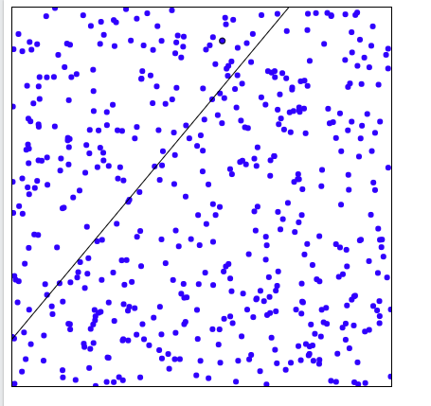

Compute Correct Answers
Compute the correct answers based on the line function:
y = x * 1.2 + 50.
The desired answer is 1 if y is over the line and 0 if y is under the line.
Store the desired answers in an array (desired[]).

Example
let desired = [];
for (let i = 0; i < numPoints; i++) {
desired[i] = 0;
if (yPoints[i] > f(xPoints[i])) {desired[i] = 1;}
}

Display the Correct Answers
For each point, if desired[i] = 1 display a black point, else display a blue point.

Example
for (let i = 0; i < numPoints; i++) {
let color = "blue";
if (desired[i]) color = "black";
plotter.plotPoint(xPoints[i], yPoints[i], color);
}
Try it Yourself »

<!DOCTYPE html>

<html>

<script src="myplotlib.js"></script>

<body>

<canvas id="myCanvas" width="400px" height="400px" style="width:100%;max-width:400px;border:1px solid black"></canvas>

<script>

// Create a Plotter

const plotter = new XYPlotter("myCanvas");

plotter.transformXY();

const xMax = plotter.xMax;

const yMax = plotter.yMax;

const xMin = plotter.xMin;

const yMin = plotter.yMin;

// Create Random XY Points

const numPoints = 500;

const xPoints = [];

const yPoints = [];

for (let i = 0; i < numPoints; i++) {

xPoints[i] = Math.random() * xMax;

yPoints[i] = Math.random() * yMax;

}

// Line Function

function f(x) {

return x * 1.2 + 50;

}

//Plot the Line

plotter.plotLine(xMin, f(xMin), xMax, f(xMax), "black");

// Compute Desired Answers

const desired = [];

for (let i = 0; i < numPoints; i++) {

desired[i] = 0;

if (yPoints[i] > f(xPoints[i])) {desired[i] = 1}

}

// Diplay Desired Result

for (let i = 0; i < numPoints; i++) {

let color = "blue";

if (desired[i]) color = "black";

plotter.plotPoint(xPoints[i], yPoints[i], color);

}

</script>

</body>

</html>

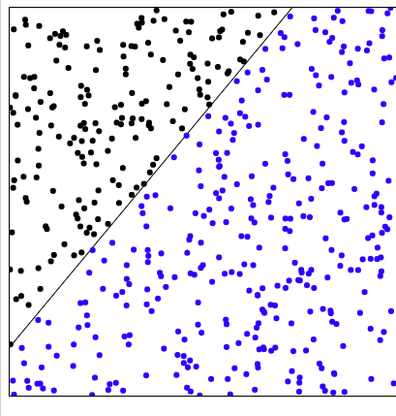

How to Train a Perceptron
In the next chapter, you will learn how to use the correct answers to:
Train a perceptron to predict the output values of unknown input values.

Machine Learning - Mean Median Mode

Mean, Median, and Mode
What can we learn from looking at a group of numbers?
In Machine Learning (and in mathematics) there are often three values that interests us:
- Mean - The average value
- Median - The mid point value
- Mode - The most common value
Example: We have registered the speed of 13 cars:
speed = [99,86,87,88,111,86,103,87,94,78,77,85,86]
What is the average, the middle, or the most common speed value?

Mean
The mean value is the average value.
To calculate the mean, find the sum of all values, and divide the sum by the number of values:
(99+86+87+88+111+86+103+87+94+78+77+85+86) / 13 = 89.77
The NumPy module has a method for this. Learn about the NumPy module in our NumPy Tutorial.

ExampleGet your own Python Server
Use the NumPy mean() method to find the average speed:
import numpy
speed = [99,86,87,88,111,86,103,87,94,78,77,85,86]
x = numpy.mean(speed)
print(x)
result:
89.76923076923077

Median
The median value is the value in the middle, after you have sorted all the values:
77, 78, 85, 86, 86, 86, 87, 87, 88, 94, 99, 103, 111
It is important that the numbers are sorted before you can find the median.
The NumPy module has a method for this:

Example
Use the NumPy median() method to find the middle value:
import numpy
speed = [99,86,87,88,111,86,103,87,94,78,77,85,86]
x = numpy.median(speed)
print(x)
If there are two numbers in the middle, divide the sum of those numbers by two.
77, 78, 85, 86, 86, 86, 87, 87, 94, 98, 99, 103
(86 + 87) / 2 = 86.5

Example
Using the NumPy module:
import numpy
speed = [99,86,87,88,86,103,87,94,78,77,85,86]
x = numpy.median(speed)
print(x)
result:86.5

Mode
The Mode value is the value that appears the most number of times:
99, 86, 87, 88, 111, 86, 103, 87, 94, 78, 77, 85, 86 = 86
The SciPy module has a method for this. Learn about the SciPy module in our SciPy Tutorial.

Example
Use the SciPy mode() method to find the number that appears the most:
from scipy import stats
speed = [99,86,87,88,111,86,103,87,94,78,77,85,86]
x = stats.mode(speed)
print(x)
result:
ModeResult(mode=array([86]), count=array([3]))

What is Standard Deviation?
Standard deviation is a number that describes how spread out the values are.
A low standard deviation means that most of the numbers are close to the mean (average) value.
A high standard deviation means that the values are spread out over a wider range.
Example: This time we have registered the speed of 7 cars:
speed = [86,87,88,86,87,85,86]
The standard deviation is:
0.9
Meaning that most of the values are within the range of 0.9 from the mean value, which is 86.4.
Let us do the same with a selection of numbers with a wider range:
speed = [32,111,138,28,59,77,97]
The standard deviation is:
37.85
Meaning that most of the values are within the range of 37.85 from the mean value, which is 77.4.
As you can see, a higher standard deviation indicates that the values are spread out over a wider range.
The NumPy module has a method to calculate the standard deviation:

ExampleGet your own Python Server
Use the NumPy std() method to find the standard deviation:
import numpy
speed = [86,87,88,86,87,85,86]
x = numpy.std(speed)
print(x)
Result:
0.9035079029052513

Example
import numpy
speed = [32,111,138,28,59,77,97]
x = numpy.std(speed)
print(x)
Result: 37.84501153334721
37.8450115333472

Variance
Variance is another number that indicates how spread out the values are.
In fact, if you take the square root of the variance, you get the standard deviation!
Or the other way around, if you multiply the standard deviation by itself, you get the variance!
To calculate the variance you have to do as follows:
1. Find the mean:
(32+111+138+28+59+77+97) / 7 = 77.4
2. For each value: find the difference from the mean:
32 - 77.4 = -45.4
111 - 77.4 = 33.6
138 - 77.4 = 60.6
28 - 77.4 = -49.4
59 - 77.4 = -18.4
77 - 77.4 = - 0.4
97 - 77.4 = 19.6
3. For each difference: find the square value:
(-45.4)² = 2061.16
(33.6)² = 1128.96
(60.6)² = 3672.36
(-49.4)² = 2440.36
(-18.4)² = 338.56
(- 0.4)² = 0.16
(19.6)² = 384.16
4. The variance is the average number of these squared differences:
(2061.16+1128.96+3672.36+2440.36+338.56+0.16+384.16) / 7 = 1432.2
Luckily, NumPy has a method to calculate the variance:

Example
Use the NumPy var() method to find the variance:
import numpy
speed = [32,111,138,28,59,77,97]
x = numpy.var(speed)
print(x)
Result
​
1432.2448979591834

Standard Deviation
As we have learned, the formula to find the standard deviation is the square root of the variance:
√1432.25 = 37.85
Or, as in the example from before, use the NumPy to calculate the standard deviation:

Example
Use the NumPy std() method to find the standard deviation:
import numpy
speed = [32,111,138,28,59,77,97]
x = numpy.std(speed)
print(x)
Result:
​
37.84501153334721

Machine Learning - Data Distribution

Data Distribution
Earlier in this tutorial we have worked with very small amounts of data in our examples, just to understand the different concepts.
In the real world, the data sets are much bigger, but it can be difficult to gather real world data, at least at an early stage of a project.

How Can we Get Big Data Sets?
To create big data sets for testing, we use the Python module NumPy, which comes with a number of methods to create random data sets, of any size.

ExampleGet your own Python Server
Create an array containing 250 random floats between 0 and 5:
import numpy
x = numpy.random.uniform(0.0, 5.0, 250)
print(x)
[1.31139138 3.68254343 4.72910475 0.25497053 4.46715005 4.69063926
4.64923705 3.45047106 2.41635247 2.72443332 2.20898575 4.75086617
0.40901702 1.74418731 0.61052823 4.31924024 0.81246772 3.65634772
4.4368116 0.28534843 1.52660889 0.10930926 3.17271227 1.53939643
2.57415792 1.85451652 3.25557744 0.45683691 3.55724599 1.20144077
4.3503184 2.08016568 4.2806164 1.11560441 0.9837929 4.51541708
4.30668544 1.26976371 2.91607325 3.64874234 4.1319259 0.43391824
1.60413992 1.13268393 2.5471422 4.17372757 2.39691211 1.09590849
0.78324923 3.28075845 3.67161525 1.90254799 4.44315953 2.45033939
3.63806989 4.09826973 3.24514784 4.86310592 3.62200117 0.85001856
3.50022126 2.36443496 2.87611833 0.60288709 3.58445855 4.60662207
4.58906218 1.36240638 4.72090746 2.03314772 2.70775933 4.45980053
2.39425003 0.45391295 3.86857402 3.84125436 3.85906983 3.64325778
4.85526522 2.29786611 0.08203303 2.13789532 1.96102399 2.18950022
1.48765372 1.81315182 4.66093633 1.45881744 4.82293412 2.55849424
4.78892817 0.15698028 4.73209065 4.33109559 4.38915542 0.21859371
1.79201347 0.78620987 0.85987841 3.44912414 3.5526567 3.73588221
2.7203951 3.36016902 2.62962832 1.58537506 4.44309042 1.90639388
4.27884349 1.2822825 0.12100824 1.35407357 3.16081019 1.88758927
3.12187993 2.38354404 4.33684267 4.8608494 0.01053712 1.13334692
1.09513219 0.73156304 4.00165639 0.53747497 1.64921499 4.64347933
0.97870812 4.86628269 4.86455284 0.93495425 0.37820159 3.82521254
0.18608466 2.74196215 4.91077966 3.11112852 2.60927451 4.06674067
3.44957268 1.15060278 3.40424508 3.97212824 4.1625332 0.83988759
3.62917845 2.00386269 1.3421589 3.02633995 4.23743393 4.26563947
1.29885407 4.32064455 0.32446988 3.66345188 4.20062797 3.2582097
4.37327245 2.68963454 0.3114567 1.33135248 4.15748255 2.88971477
2.00938395 0.56740139 2.66392737 4.13470747 2.68392016 3.78864162
2.4688611 4.86621184 4.2673624 1.63592588 4.52378971 2.74945213
2.09048184 4.47103629 0.08483193 4.69907362 4.53365294 1.56938497
4.50072788 3.68473039 4.79427073 4.80067463 3.94440361 1.66701378
4.98922345 3.74875516 3.22297622 2.0932426 4.83154332 0.30134755
4.69531394 4.32967023 4.14506186 0.02475297 3.51075946 4.71530412
0.93762777 0.80102813 0.09615941 2.26998717 4.23700946 2.11438189
0.52114366 1.18932841 0.38480121 1.04118676 4.31354798 1.97096473
2.98589467 0.80951513 2.68179859 0.94436684 3.44401835 2.60507932
3.0062746 4.55014803 0.08452494 0.78698432 0.85046967 1.46185572
2.01362126 3.35885638 0.22329417 4.17987916 2.3781314 2.16506978
2.62520736 3.57674984 1.68385993 2.3392743 1.45140455 1.0849837
3.40502325 4.92823781 1.67021066 1.74225867 2.84510479 4.0927335
2.52568528 0.39791545 0.76186615 3.7455257 0.22157656 0.10812358
4.77228033 1.50739238 2.44913012 2.76617713]

Histogram
To visualize the data set we can draw a histogram with the data we collected.
We will use the Python module Matplotlib to draw a histogram.
Learn about the Matplotlib module in our Matplotlib Tutorial.

Example
Draw a histogram:
import numpy
import matplotlib.pyplot as plt
x = numpy.random.uniform(0.0, 5.0, 250)
plt.hist(x, 5)
plt.show()
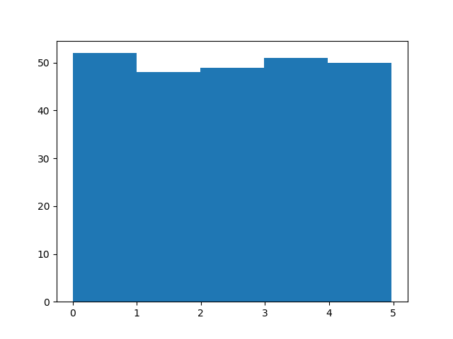
#Three lines to make our compiler able to draw:
import sys
import matplotlib
matplotlib.use('Agg')

import numpy
import matplotlib.pyplot as plt

x = numpy.random.uniform(0.0, 5.0, 250)

plt.hist(x, 5)
plt.show()

#Two lines to make our compiler able to draw:
plt.savefig(sys.stdout.buffer)
sys.stdout.flush()
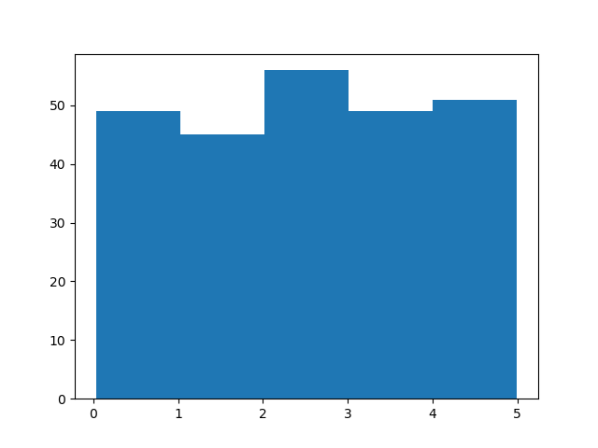

Histogram Explained
We use the array from the example above to draw a histogram with 5 bars.
The first bar represents how many values in the array are between 0 and 1.
The second bar represents how many values are between 1 and 2.
Etc.
Which gives us this result:
- 52 values are between 0 and 1
- 48 values are between 1 and 2
- 49 values are between 2 and 3
- 51 values are between 3 and 4
- 50 values are between 4 and 5
Note: The array values are random numbers and will not show the exact same result on your computer.

Big Data Distributions
An array containing 250 values is not considered very big, but now you know how to create a random set of values, and by changing the parameters, you can create the data set as big as you want.

Example
Create an array with 100000 random numbers, and display them using a histogram with 100 bars:
import numpy
import matplotlib.pyplot as plt
x = numpy.random.uniform(0.0, 5.0, 100000)
plt.hist(x, 100)
plt.show()

#Three lines to make our compiler able to draw:
import sys
import matplotlib
matplotlib.use('Agg')

import numpy
import matplotlib.pyplot as plt

x = numpy.random.uniform(0.0, 5.0, 100000)

plt.hist(x, 100)
plt.show()

#Two lines to make our compiler able to draw:
plt.savefig(sys.stdout.buffer)
sys.stdout.flush()

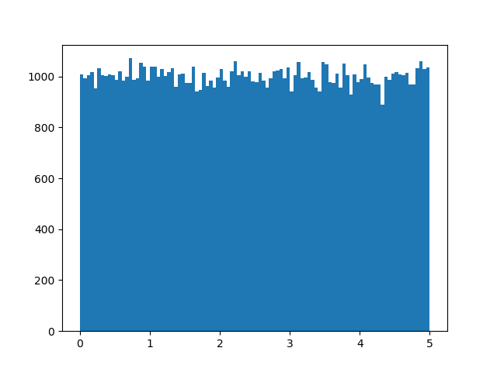

Machine Learning - Normal Data Distribution

Normal Data Distribution
In the previous chapter we learned how to create a completely random array, of a given size, and between two given values.
In this chapter we will learn how to create an array where the values are concentrated around a given value.
In probability theory this kind of data distribution is known as the normal data distribution, or the Gaussian data distribution, after the mathematician Carl Friedrich Gauss who came up with the formula of this data distribution.

ExampleGet your own Python Server
A typical normal data distribution:
import numpy
import matplotlib.pyplot as plt
x = numpy.random.normal(5.0, 1.0, 100000)
plt.hist(x, 100)
plt.show()

#Three lines to make our compiler able to draw:
import sys
import matplotlib
matplotlib.use('Agg')

import numpy
import matplotlib.pyplot as plt

x = numpy.random.normal(5.0, 1.0, 100000)

plt.hist(x, 100)
plt.show()

#Two lines to make our compiler able to draw:
plt.savefig(sys.stdout.buffer)
sys.stdout.flush()

Note: A normal distribution graph is also known as the bell curve because of it's characteristic shape of a bell.

Histogram Explained
We use the array from the numpy.random.normal() method, with 100000 values, to draw a histogram with 100 bars.
We specify that the mean value is 5.0, and the standard deviation is 1.0.
Meaning that the values should be concentrated around 5.0, and rarely further away than 1.0 from the mean.
And as you can see from the histogram, most values are between 4.0 and 6.0, with a top at approximately 5.0.

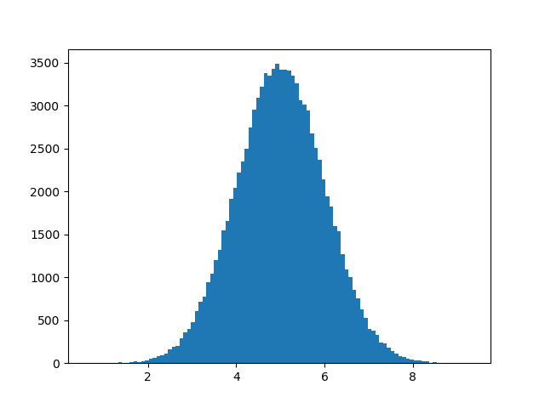

Machine Learning - Scatter Plot

Scatter Plot
A scatter plot is a diagram where each value in the data set is represented by a dot.
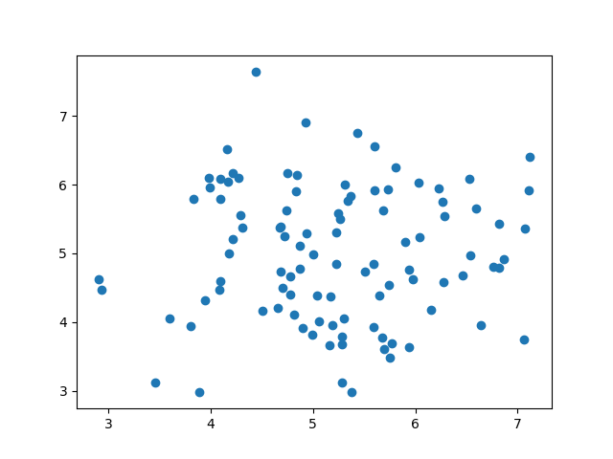
The Matplotlib module has a method for drawing scatter plots, it needs two arrays of the same length, one for the values of the x-axis, and one for the values of the y-axis:
x = [5,7,8,7,2,17,2,9,4,11,12,9,6]
y = [99,86,87,88,111,86,103,87,94,78,77,85,86]
The x array represents the age of each car.
The y array represents the speed of each car.

ExampleGet your own Python Server
Use the scatter() method to draw a scatter plot diagram:
import matplotlib.pyplot as plt
x = [5,7,8,7,2,17,2,9,4,11,12,9,6]
y = [99,86,87,88,111,86,103,87,94,78,77,85,86]
plt.scatter(x, y)
plt.show()

Result:

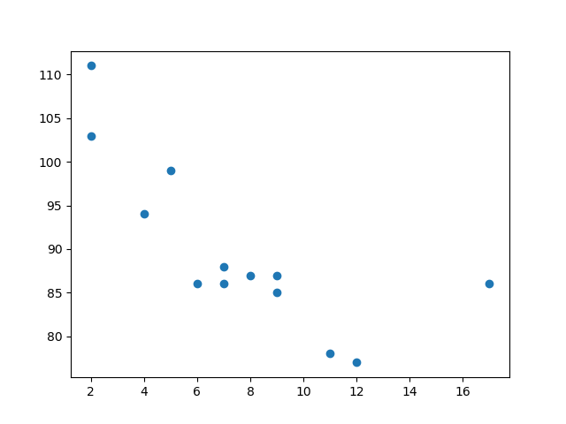

#Three lines to make our compiler able to draw:
import sys
import matplotlib
matplotlib.use('Agg')

import matplotlib.pyplot as plt

x = [5,7,8,7,2,17,2,9,4,11,12,9,6]
y = [99,86,87,88,111,86,103,87,94,78,77,85,86]

plt.scatter(x, y)
plt.show()

#Two lines to make our compiler able to draw:
plt.savefig(sys.stdout.buffer)
sys.stdout.flush()

Scatter Plot Explained
The x-axis represents ages, and the y-axis represents speeds.
What we can read from the diagram is that the two fastest cars were both 2 years old, and the slowest car was 12 years old.
Note: It seems that the newer the car, the faster it drives, but that could be a coincidence, after all we only registered 13 cars.

Random Data Distributions
In Machine Learning the data sets can contain thousands-, or even millions, of values.
You might not have real world data when you are testing an algorithm, you might have to use randomly generated values.
As we have learned in the previous chapter, the NumPy module can help us with that!
Let us create two arrays that are both filled with 1000 random numbers from a normal data distribution.
The first array will have the mean set to 5.0 with a standard deviation of 1.0.
The second array will have the mean set to 10.0 with a standard deviation of 2.0:

Example
A scatter plot with 1000 dots:
import numpy
import matplotlib.pyplot as plt
x = numpy.random.normal(5.0, 1.0, 1000)
y = numpy.random.normal(10.0, 2.0, 1000)
plt.scatter(x, y)
plt.show()

Result:
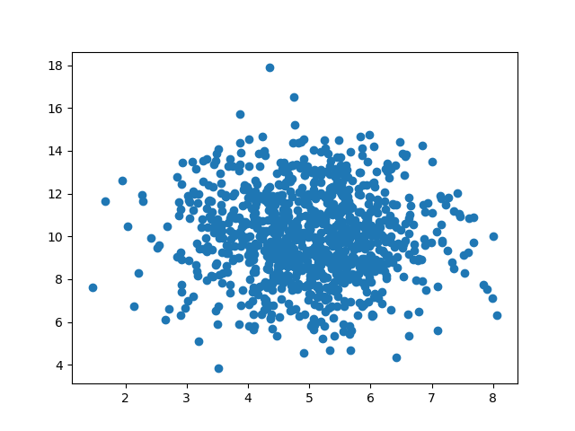
#Three lines to make our compiler able to draw:
import sys
import matplotlib
matplotlib.use('Agg')

import numpy
import matplotlib.pyplot as plt

x = numpy.random.normal(5.0, 1.0, 1000)
y = numpy.random.normal(10.0, 2.0, 1000)

plt.scatter(x, y)
plt.show()

#Two lines to make our compiler able to draw:
plt.savefig(sys.stdout.buffer)
sys.stdout.flush()

Scatter Plot Explained
We can see that the dots are concentrated around the value 5 on the x-axis, and 10 on the y-axis.
We can also see that the spread is wider on the y-axis than on the x-axis.

Machine Learning - Linear Regression

Regression
The term regression is used when you try to find the relationship between variables.
In Machine Learning, and in statistical modeling, that relationship is used to predict the outcome of future events.

Linear Regression
Linear regression uses the relationship between the data-points to draw a straight line through all them.
This line can be used to predict future values.
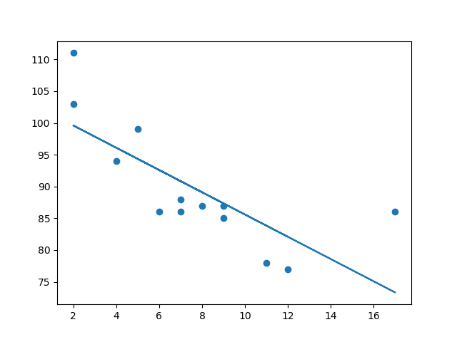
In Machine Learning, predicting the future is very important.

How Does it Work?
Python has methods for finding a relationship between data-points and to draw a line of linear regression. We will show you how to use these methods instead of going through the mathematic formula.
In the example below, the x-axis represents age, and the y-axis represents speed. We have registered the age and speed of 13 cars as they were passing a tollbooth. Let us see if the data we collected could be used in a linear regression:

ExampleGet your own Python Server
Start by drawing a scatter plot:
import matplotlib.pyplot as plt
x = [5,7,8,7,2,17,2,9,4,11,12,9,6]
y = [99,86,87,88,111,86,103,87,94,78,77,85,86]
plt.scatter(x, y)
plt.show()

Result:

#Three lines to make our compiler able to draw:
import sys
import matplotlib
matplotlib.use('Agg')

import matplotlib.pyplot as plt

x = [5,7,8,7,2,17,2,9,4,11,12,9,6]
y = [99,86,87,88,111,86,103,87,94,78,77,85,86]

plt.scatter(x, y)
plt.show()

#Two lines to make our compiler able to draw:
plt.savefig(sys.stdout.buffer)
sys.stdout.flush()

Example
Import scipy and draw the line of Linear Regression:
import matplotlib.pyplot as plt
from scipy import stats
x = [5,7,8,7,2,17,2,9,4,11,12,9,6]
y = [99,86,87,88,111,86,103,87,94,78,77,85,86]
slope, intercept, r, p, std_err = stats.linregress(x, y)
def myfunc(x):
return slope * x + intercept
mymodel = list(map(myfunc, x))
plt.scatter(x, y)
plt.plot(x, mymodel)
plt.show()

#Three lines to make our compiler able to draw:
import sys
import matplotlib
matplotlib.use('Agg')

import matplotlib.pyplot as plt
from scipy import stats

x = [5,7,8,7,2,17,2,9,4,11,12,9,6]
y = [99,86,87,88,111,86,103,87,94,78,77,85,86]

slope, intercept, r, p, std_err = stats.linregress(x, y)

def myfunc(x):
return slope * x + intercept

mymodel = list(map(myfunc, x))

plt.scatter(x, y)
plt.plot(x, mymodel)
plt.show()

#Two lines to make our compiler able to draw:
plt.savefig(sys.stdout.buffer)
sys.stdout.flush()

Example Explained
Import the modules you need.
You can learn about the Matplotlib module in our Matplotlib Tutorial.
You can learn about the SciPy module in our SciPy Tutorial.
import matplotlib.pyplot as plt
from scipy import stats
Create the arrays that represent the values of the x and y axis:
x = [5,7,8,7,2,17,2,9,4,11,12,9,6]
y = [99,86,87,88,111,86,103,87,94,78,77,85,86]
Execute a method that returns some important key values of Linear Regression:
slope, intercept, r, p, std_err = stats.linregress(x, y)
Create a function that uses the slope and intercept values to return a new value. This new value represents where on the y-axis the corresponding x value will be placed:
def myfunc(x):
return slope * x + intercept
Run each value of the x array through the function. This will result in a new array with new values for the y-axis:
mymodel = list(map(myfunc, x))
Draw the original scatter plot:
plt.scatter(x, y)
Draw the line of linear regression:
plt.plot(x, mymodel)
Display the diagram:
plt.show()

R for Relationship
It is important to know how the relationship between the values of the x-axis and the values of the y-axis is, if there are no relationship the linear regression can not be used to predict anything.
This relationship - the coefficient of correlation - is called r.
The r value ranges from -1 to 1, where 0 means no relationship, and 1 (and -1) means 100% related.
Python and the Scipy module will compute this value for you, all you have to do is feed it with the x and y values.

Example
How well does my data fit in a linear regression?
from scipy import stats
x = [5,7,8,7,2,17,2,9,4,11,12,9,6]
y = [99,86,87,88,111,86,103,87,94,78,77,85,86]
slope, intercept, r, p, std_err = stats.linregress(x, y)
print(r)
0.758591524376155
Note: The result -0.76 shows that there is a relationship, not perfect, but it indicates that we could use linear regression in future predictions.

Predict Future Values
Now we can use the information we have gathered to predict future values.
Example: Let us try to predict the speed of a 10 years old car.
To do so, we need the same myfunc() function from the example above:
def myfunc(x):
return slope * x + intercept

Example
Predict the speed of a 10 years old car:
from scipy import stats
x = [5,7,8,7,2,17,2,9,4,11,12,9,6]
y = [99,86,87,88,111,86,103,87,94,78,77,85,86]
slope, intercept, r, p, std_err = stats.linregress(x, y)
def myfunc(x):
return slope * x + intercept
speed = myfunc(10)
print(speed)
Run example »
from scipy import stats

x = [5,7,8,7,2,17,2,9,4,11,12,9,6]
y = [99,86,87,88,111,86,103,87,94,78,77,85,86]

slope, intercept, r, p, std_err = stats.linregress(x, y)

def myfunc(x):
return slope * x + intercept

speed = myfunc(10)

print(speed)
85.59308314937454
The example predicted a speed at 85.6, which we also could read from the diagram:
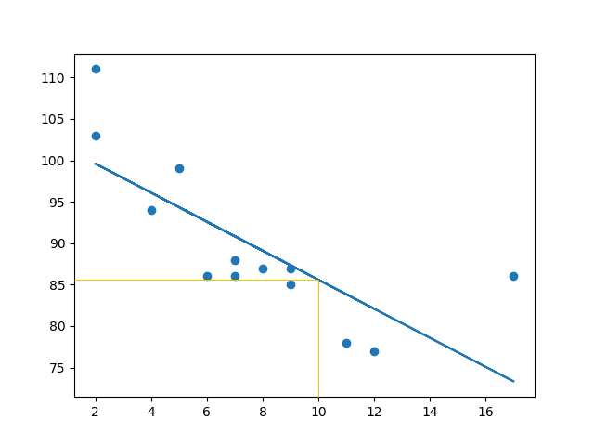

Bad Fit?
Let us create an example where linear regression would not be the best method to predict future values.

Example
These values for the x- and y-axis should result in a very bad fit for linear regression:
import matplotlib.pyplot as plt
from scipy import stats
x = [89,43,36,36,95,10,66,34,38,20,26,29,48,64,6,5,36,66,72,40]
y = [21,46,3,35,67,95,53,72,58,10,26,34,90,33,38,20,56,2,47,15]
slope, intercept, r, p, std_err = stats.linregress(x, y)
def myfunc(x):
return slope * x + intercept
mymodel = list(map(myfunc, x))
plt.scatter(x, y)
plt.plot(x, mymodel)
plt.show()
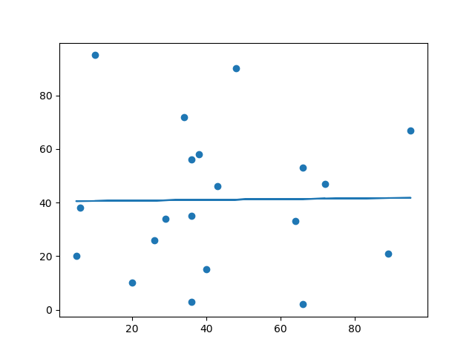
#Three lines to make our compiler able to draw:
import sys
import matplotlib
matplotlib.use('Agg')

import matplotlib.pyplot as plt
from scipy import stats

x = [89,43,36,36,95,10,66,34,38,20,26,29,48,64,6,5,36,66,72,40]
y = [21,46,3,35,67,95,53,72,58,10,26,34,90,33,38,20,56,2,47,15]

slope, intercept, r, p, std_err = stats.linregress(x, y)

def myfunc(x):
return slope * x + intercept

mymodel = list(map(myfunc, x))

plt.scatter(x, y)
plt.plot(x, mymodel)
plt.show()

#Two lines to make our compiler able to draw:
plt.savefig(sys.stdout.buffer)
sys.stdout.flush()

And the r for relationship?

Example
You should get a very low r value.
import numpy
from scipy import stats
x = [89,43,36,36,95,10,66,34,38,20,26,29,48,64,6,5,36,66,72,40]
y = [21,46,3,35,67,95,53,72,58,10,26,34,90,33,38,20,56,2,47,15]
slope, intercept, r, p, std_err = stats.linregress(x, y)
print(r)
0.01331814154297491

Machine Learning - Polynomial Regression

Polynomial Regression
If your data points clearly will not fit a linear regression (a straight line through all data points), it might be ideal for polynomial regression.
Polynomial regression, like linear regression, uses the relationship between the variables x and y to find the best way to draw a line through the data points.
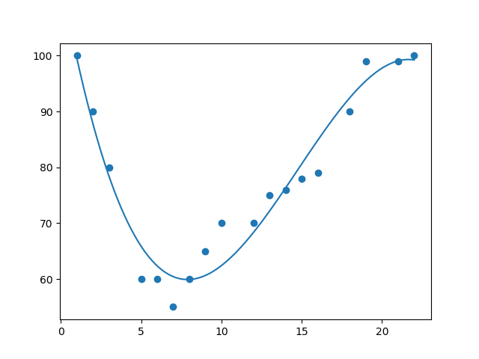

How Does it Work?
Python has methods for finding a relationship between data-points and to draw a line of polynomial regression. We will show you how to use these methods instead of going through the mathematic formula.
In the example below, we have registered 18 cars as they were passing a certain tollbooth.
We have registered the car's speed, and the time of day (hour) the passing occurred.
The x-axis represents the hours of the day and the y-axis represents the speed:

ExampleGet your own Python Server
Start by drawing a scatter plot:
import matplotlib.pyplot as plt
x = [1,2,3,5,6,7,8,9,10,12,13,14,15,16,18,19,21,22]
y = [100,90,80,60,60,55,60,65,70,70,75,76,78,79,90,99,99,100]
plt.scatter(x, y)
plt.show()

Result:
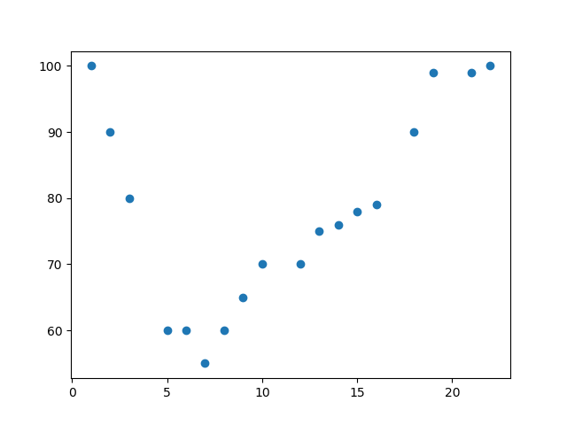
#Three lines to make our compiler able to draw:
import sys
import matplotlib
matplotlib.use('Agg')

import matplotlib.pyplot as plt

x = [1,2,3,5,6,7,8,9,10,12,13,14,15,16,18,19,21,22]
y = [100,90,80,60,60,55,60,65,70,70,75,76,78,79,90,99,99,100]

plt.scatter(x, y)
plt.show()

#Two lines to make our compiler able to draw:
plt.savefig(sys.stdout.buffer)
sys.stdout.flush()

Example
Import numpy and matplotlib then draw the line of Polynomial Regression:
import numpy
import matplotlib.pyplot as plt
x = [1,2,3,5,6,7,8,9,10,12,13,14,15,16,18,19,21,22]
y = [100,90,80,60,60,55,60,65,70,70,75,76,78,79,90,99,99,100]
mymodel = numpy.poly1d(numpy.polyfit(x, y, 3))
myline = numpy.linspace(1, 22, 100)
plt.scatter(x, y)
plt.plot(myline, mymodel(myline))
plt.show()

Result:

#Three lines to make our compiler able to draw:
import sys
import matplotlib
matplotlib.use('Agg')

import numpy
import matplotlib.pyplot as plt

x = [1,2,3,5,6,7,8,9,10,12,13,14,15,16,18,19,21,22]
y = [100,90,80,60,60,55,60,65,70,70,75,76,78,79,90,99,99,100]

mymodel = numpy.poly1d(numpy.polyfit(x, y, 3))

myline = numpy.linspace(1, 22, 100)

plt.scatter(x, y)
plt.plot(myline, mymodel(myline))
plt.show()

#Two lines to make our compiler able to draw:
plt.savefig(sys.stdout.buffer)
sys.stdout.flush()

Example Explained
Import the modules you need.
You can learn about the NumPy module in our NumPy Tutorial.
You can learn about the SciPy module in our SciPy Tutorial.
import numpy
import matplotlib.pyplot as plt
Create the arrays that represent the values of the x and y axis:
x = [1,2,3,5,6,7,8,9,10,12,13,14,15,16,18,19,21,22]
y = [100,90,80,60,60,55,60,65,70,70,75,76,78,79,90,99,99,100]
NumPy has a method that lets us make a polynomial model:
mymodel = numpy.poly1d(numpy.polyfit(x, y, 3))
Then specify how the line will display, we start at position 1, and end at position 22:
myline = numpy.linspace(1, 22, 100)
Draw the original scatter plot:
plt.scatter(x, y)
Draw the line of polynomial regression:
plt.plot(myline, mymodel(myline))
Display the diagram:
plt.show()

R-Squared
It is important to know how well the relationship between the values of the x- and y-axis is, if there are no relationship the polynomial regression can not be used to predict anything.
The relationship is measured with a value called the r-squared.
The r-squared value ranges from 0 to 1, where 0 means no relationship, and 1 means 100% related.
Python and the Sklearn module will compute this value for you, all you have to do is feed it with the x and y arrays:

Example
How well does my data fit in a polynomial regression?
import numpy
from sklearn.metrics import r2_score
x = [1,2,3,5,6,7,8,9,10,12,13,14,15,16,18,19,21,22]
y = [100,90,80,60,60,55,60,65,70,70,75,76,78,79,90,99,99,100]
mymodel = numpy.poly1d(numpy.polyfit(x, y, 3))
print(r2_score(y, mymodel(x))
.9432150416451027
Note: The result 0.94 shows that there is a very good relationship, and we can use polynomial regression in future predictions.

Predict Future Values
Now we can use the information we have gathered to predict future values.
Example: Let us try to predict the speed of a car that passes the tollbooth at around the time 17:00:
To do so, we need the same mymodel array from the example above:
mymodel = numpy.poly1d(numpy.polyfit(x, y, 3))

Example
Predict the speed of a car passing at 17:00:
import numpy
from sklearn.metrics import r2_score
x = [1,2,3,5,6,7,8,9,10,12,13,14,15,16,18,19,21,22]
y = [100,90,80,60,60,55,60,65,70,70,75,76,78,79,90,99,99,100]
mymodel = numpy.poly1d(numpy.polyfit(x, y, 3))
speed = mymodel(17)
print(speed)

88.87331269697987

The example predicted a speed to be 88.87, which we also could read from the diagram: 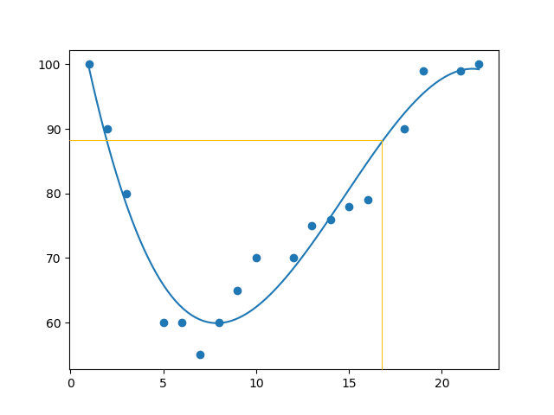

Bad Fit?
Let us create an example where polynomial regression would not be the best method to predict future values.

Example
These values for the x- and y-axis should result in a very bad fit for polynomial regression:
import numpy
import matplotlib.pyplot as plt
x = [89,43,36,36,95,10,66,34,38,20,26,29,48,64,6,5,36,66,72,40]
y = [21,46,3,35,67,95,53,72,58,10,26,34,90,33,38,20,56,2,47,15]
mymodel = numpy.poly1d(numpy.polyfit(x, y, 3))
myline = numpy.linspace(2, 95, 100)
plt.scatter(x, y)
plt.plot(myline, mymodel(myline))
plt.show()

Result:
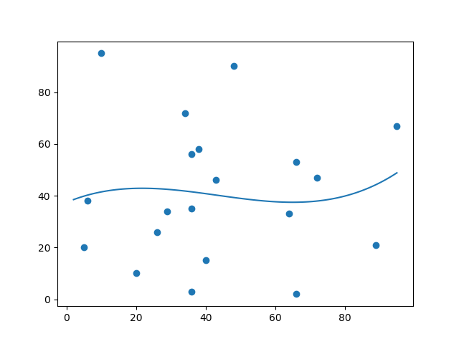
#Three lines to make our compiler able to draw:
import sys
import matplotlib
matplotlib.use('Agg')

import numpy
import matplotlib.pyplot as plt

x = [89,43,36,36,95,10,66,34,38,20,26,29,48,64,6,5,36,66,72,40]
y = [21,46,3,35,67,95,53,72,58,10,26,34,90,33,38,20,56,2,47,15]

mymodel = numpy.poly1d(numpy.polyfit(x, y, 3))

myline = numpy.linspace(2, 95, 100)

plt.scatter(x, y)
plt.plot(myline, mymodel(myline))
plt.show()

#Two lines to make our compiler able to draw:
plt.savefig(sys.stdout.buffer)
sys.stdout.flush()
And the r-squared value?

Example
You should get a very low r-squared value.
import numpy
from sklearn.metrics import r2_score
x = [89,43,36,36,95,10,66,34,38,20,26,29,48,64,6,5,36,66,72,40]
y = [21,46,3,35,67,95,53,72,58,10,26,34,90,33,38,20,56,2,47,15]
mymodel = numpy.poly1d(numpy.polyfit(x, y, 3))
print(r2_score(y, mymodel(x)))
​
0.009952707566680652

Multiple Regression
Multiple regression is like linear regression, but with more than one independent value, meaning that we try to predict a value based on two or more variables.
Take a look at the data set below, it contains some information about cars.
ar | Model | Volume | Weight | CO2

Toyota | Aygo | 1000 | 790 | 99
Mitsubishi | Space Star | 1200 | 1160 | 95
Skoda | Citigo | 1000 | 929 | 95
Fiat | 500 | 900 | 865 | 90
Mini | Cooper | 1500 | 1140 | 105
VW | Up! | 1000 | 929 | 105
Skoda | Fabia | 1400 | 1109 | 90
Mercedes | A-Class | 1500 | 1365 | 92
Ford | Fiesta | 1500 | 1112 | 98
Audi | A1 | 1600 | 1150 | 99
Hyundai | I20 | 1100 | 980 | 99
Suzuki | Swift | 1300 | 990 | 101
Ford | Fiesta | 1000 | 1112 | 99
Honda | Civic | 1600 | 1252 | 94
Hundai | I30 | 1600 | 1326 | 97
Opel | Astra | 1600 | 1330 | 97
BMW | 1 | 1600 | 1365 | 99
Mazda | 3 | 2200 | 1280 | 104
Skoda | Rapid | 1600 | 1119 | 104
Ford | Focus | 2000 | 1328 | 105
Ford | Mondeo | 1600 | 1584 | 94
Opel | Insignia | 2000 | 1428 | 99
Mercedes | C-Class | 2100 | 1365 | 99
Skoda | Octavia | 1600 | 1415 | 99
Volvo | S60 | 2000 | 1415 | 99
Mercedes | CLA | 1500 | 1465 | 102
Audi | A4 | 2000 | 1490 | 104
Audi | A6 | 2000 | 1725 | 114
Volvo | V70 | 1600 | 1523 | 109
BMW | 5 | 2000 | 1705 | 114
Mercedes | E-Class | 2100 | 1605 | 115
Volvo | XC70 | 2000 | 1746 | 117
Ford | B-Max | 1600 | 1235 | 104
BMW | 2 | 1600 | 1390 | 108
Opel | Zafira | 1600 | 1405 | 109
Mercedes | SLK | 2500 | 1395 | 120
We can predict the CO2 emission of a car based on the size of the engine, but with multiple regression we can throw in more variables, like the weight of the car, to make the prediction more accurate.

How Does it Work?
In Python we have modules that will do the work for us. Start by importing the Pandas module.
import pandas
Learn about the Pandas module in our Pandas Tutorial.
The Pandas module allows us to read csv files and return a DataFrame object.
The file is meant for testing purposes only, you can download it here: data.csv
df = pandas.read_csv("data.csv")
Then make a list of the independent values and call this variable X.
Put the dependent values in a variable called y.
X = df[['Weight', 'Volume']]
y = df['CO2']
Tip: It is common to name the list of independent values with a upper case X, and the list of dependent values with a lower case y.
We will use some methods from the sklearn module, so we will have to import that module as well:
from sklearn import linear_model
From the sklearn module we will use the LinearRegression() method to create a linear regression object.
This object has a method called fit() that takes the independent and dependent values as parameters and fills the regression object with data that describes the relationship:
regr = linear_model.LinearRegression()
regr.fit(X, y)
Now we have a regression object that are ready to predict CO2 values based on a car's weight and volume:
#predict the CO2 emission of a car where the weight is 2300kg, and the volume is 1300cm³:
predictedCO2 = regr.predict([[2300, 1300]])

ExampleGet your own Python Server
See the whole example in action:
import pandas
from sklearn import linear_model
df = pandas.read_csv("data.csv")
X = df[['Weight', 'Volume']]
y = df['CO2']
regr = linear_model.LinearRegression()
regr.fit(X, y)
#predict the CO2 emission of a car where the weight is 2300kg, and the volume is 1300cm³:
predictedCO2 = regr.predict([[2300, 1300]])
print(predictedCO2)

Result:
[107.2087328]

We have predicted that a car with 1.3 liter engine, and a weight of 2300 kg, will release approximately 107 grams of CO2 for every kilometer it drives.

Coefficient
The coefficient is a factor that describes the relationship with an unknown variable.
Example: if x is a variable, then 2x is x two times. x is the unknown variable, and the number 2 is the coefficient.
In this case, we can ask for the coefficient value of weight against CO2, and for volume against CO2. The answer(s) we get tells us what would happen if we increase, or decrease, one of the independent values.

Example
Print the coefficient values of the regression object:
import pandas
from sklearn import linear_model
df = pandas.read_csv("data.csv")
X = df[['Weight', 'Volume']]
y = df['CO2']
regr = linear_model.LinearRegression()
regr.fit(X, y)
print(regr.coef_)

Result:
[0.00755095 0.00780526]
[0.00755095 0.00780526]
[0.00755095 0.00780526]

Result Explained
The result array represents the coefficient values of weight and volume.
Weight: 0.00755095
Volume: 0.00780526
These values tell us that if the weight increase by 1kg, the CO2 emission increases by 0.00755095g.
And if the engine size (Volume) increases by 1 cm³, the CO2 emission increases by 0.00780526 g.
I think that is a fair guess, but let test it!
We have already predicted that if a car with a 1300cm³ engine weighs 2300kg, the CO2 emission will be approximately 107g.
What if we increase the weight with 1000kg?

Example
Copy the example from before, but change the weight from 2300 to 3300:
import pandas
from sklearn import linear_model
df = pandas.read_csv("data.csv")
X = df[['Weight', 'Volume']]
y = df['CO2']
regr = linear_model.LinearRegression()
regr.fit(X, y)
predictedCO2 = regr.predict([[3300, 1300]])
print(predictedCO2)

Result:
[114.75968007]
We have predicted that a car with 1.3 liter engine, and a weight of 3300 kg, will release approximately 115 grams of CO2 for every kilometer it drives.
Which shows that the coefficient of 0.00755095 is correct:
107.2087328 + (1000 * 0.00755095) = 114.75968

Predict CO2 Values
The task in the Multiple Regression chapter was to predict the CO2 emission from a car when you only knew its weight and volume.
When the data set is scaled, you will have to use the scale when you predict values:

Example
Predict the CO2 emission from a 1.3 liter car that weighs 2300 kilograms:
import pandas
from sklearn import linear_model
from sklearn.preprocessing import StandardScaler
scale = StandardScaler()
df = pandas.read_csv("data.csv")
X = df[['Weight', 'Volume']]
y = df['CO2']
scaledX = scale.fit_transform(X)
regr = linear_model.LinearRegression()
regr.fit(scaledX, y)
scaled = scale.transform([[2300, 1.3]])
predictedCO2 = regr.predict([scaled[0]])
print(predictedCO2)

Result:
[107.2087328]
Run example »

Machine Learning - Train/Test

Evaluate Your Model
In Machine Learning we create models to predict the outcome of certain events, like in the previous chapter where we predicted the CO2 emission of a car when we knew the weight and engine size.
To measure if the model is good enough, we can use a method called Train/Test.

What is Train/Test
Train/Test is a method to measure the accuracy of your model.
It is called Train/Test because you split the data set into two sets: a training set and a testing set.
80% for training, and 20% for testing.
You train the model using the training set.
You test the model using the testing set.
Train the model means create the model.
Test the model means test the accuracy of the model.

Start With a Data Set
Start with a data set you want to test.
Our data set illustrates 100 customers in a shop, and their shopping habits.

ExampleGet your own Python Server
import numpy
import matplotlib.pyplot as plt
numpy.random.seed(2)
x = numpy.random.normal(3, 1, 100)
y = numpy.random.normal(150, 40, 100) / x
plt.scatter(x, y)
plt.show()

Result:
The x axis represents the number of minutes before making a purchase.
The y axis represents the amount of money spent on the purchase.

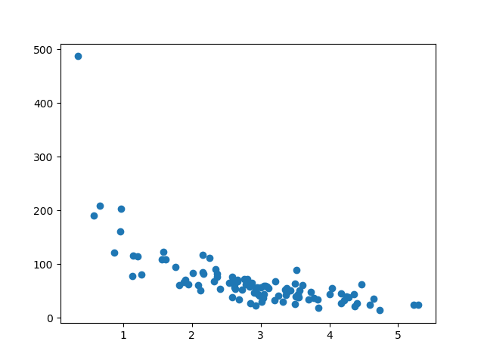
#Three lines to make our compiler able to draw:
import sys
import matplotlib
matplotlib.use('Agg')

import numpy
import matplotlib.pyplot as plt
numpy.random.seed(2)

x = numpy.random.normal(3, 1, 100)
y = numpy.random.normal(150, 40, 100) / x

plt.scatter(x, y)
plt.show()

#Two lines to make our compiler able to draw:
plt.savefig(sys.stdout.buffer)
sys.stdout.flush()

Split Into Train/Test
The training set should be a random selection of 80% of the original data.
The testing set should be the remaining 20%.
train_x = x[:80]
train_y = y[:80]
test_x = x[80:]
test_y = y[80:]

Display the Training Set
Display the same scatter plot with the training set:

Example
plt.scatter(train_x, train_y)
plt.show()

Result:
It looks like the original data set, so it seems to be a fair selection:

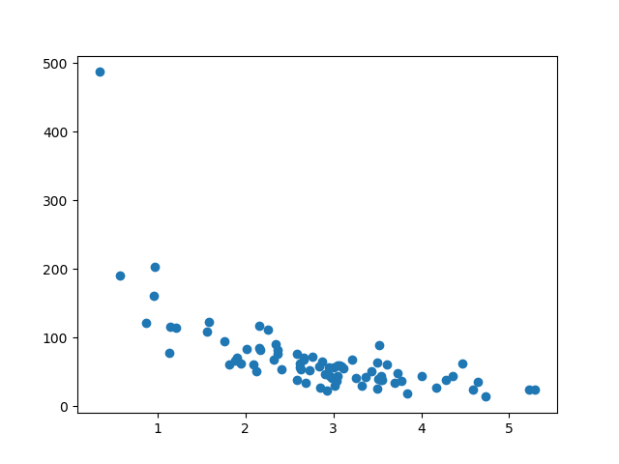
#Three lines to make our compiler able to draw:
import sys
import matplotlib
matplotlib.use('Agg')

import numpy
import matplotlib.pyplot as plt
numpy.random.seed(2)

x = numpy.random.normal(3, 1, 100)
y = numpy.random.normal(150, 40, 100) / x

train_x = x[:80]
train_y = y[:80]

test_x = x[80:]
test_y = y[80:]

plt.scatter(train_x, train_y)
plt.show()

#Two lines to make our compiler able to draw:
plt.savefig(sys.stdout.buffer)
sys.stdout.flush()

Display the Testing Set
To make sure the testing set is not completely different, we will take a look at the testing set as well.

Example
plt.scatter(test_x, test_y)
plt.show()

Result:
The testing set also looks like the original data set:

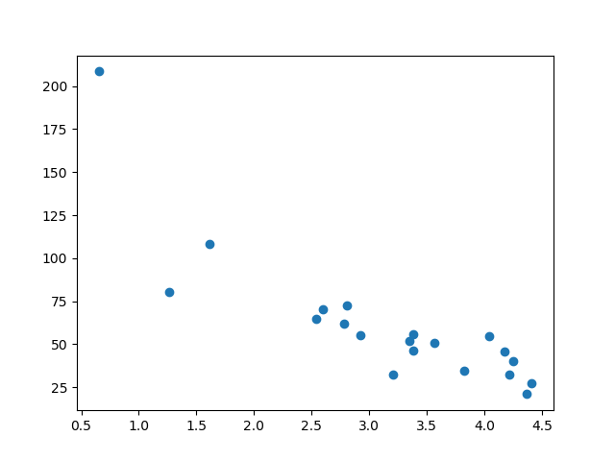
#Three lines to make our compiler able to draw:
import sys
import matplotlib
matplotlib.use('Agg')

import numpy
import matplotlib.pyplot as plt
numpy.random.seed(2)

x = numpy.random.normal(3, 1, 100)
y = numpy.random.normal(150, 40, 100) / x

train_x = x[:80]
train_y = y[:80]

test_x = x[80:]
test_y = y[80:]

plt.scatter(test_x, test_y)
plt.show()

#Two lines to make our compiler able to draw:
plt.savefig(sys.stdout.buffer)
sys.stdout.flush()

Fit the Data Set
What does the data set look like? In my opinion I think the best fit would be a polynomial regression, so let us draw a line of polynomial regression.
To draw a line through the data points, we use the plot() method of the matplotlib module:

Example
Draw a polynomial regression line through the data points:
import numpy
import matplotlib.pyplot as plt
numpy.random.seed(2)
x = numpy.random.normal(3, 1, 100)
y = numpy.random.normal(150, 40, 100) / x
train_x = x[:80]
train_y = y[:80]
test_x = x[80:]
test_y = y[80:]
mymodel = numpy.poly1d(numpy.polyfit(train_x, train_y, 4))
myline = numpy.linspace(0, 6, 100)
plt.scatter(train_x, train_y)
plt.plot(myline, mymodel(myline))
plt.show()

Result:
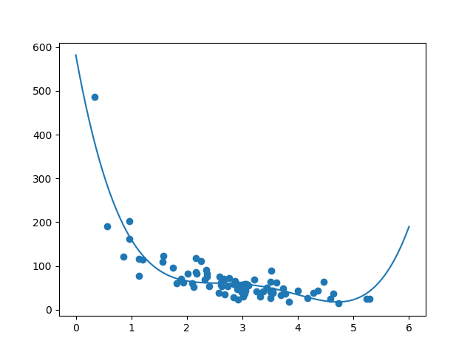
#Three lines to make our compiler able to draw:
import sys
import matplotlib
matplotlib.use('Agg')

import numpy
import matplotlib.pyplot as plt
numpy.random.seed(2)

x = numpy.random.normal(3, 1, 100)
y = numpy.random.normal(150, 40, 100) / x

train_x = x[:80]
train_y = y[:80]

test_x = x[80:]
test_y = y[80:]

mymodel = numpy.poly1d(numpy.polyfit(train_x, train_y, 3))

myline = numpy.linspace(0, 6, 100)

plt.scatter(train_x, train_y)
plt.plot(myline, mymodel(myline))
plt.show()

#Two lines to make our compiler able to draw:
plt.savefig(sys.stdout.buffer)
sys.stdout.flush()
The result can back my suggestion of the data set fitting a polynomial regression, even though it would give us some weird results if we try to predict values outside of the data set. Example: the line indicates that a customer spending 6 minutes in the shop would make a purchase worth 200. That is probably a sign of overfitting.
But what about the R-squared score? The R-squared score is a good indicator of how well my data set is fitting the model.

R2
Remember R2, also known as R-squared?
It measures the relationship between the x axis and the y axis, and the value ranges from 0 to 1, where 0 means no relationship, and 1 means totally related.
The sklearn module has a method called r2_score() that will help us find this relationship.
In this case we would like to measure the relationship between the minutes a customer stays in the shop and how much money they spend.

Example
How well does my training data fit in a polynomial regression?
import numpy
from sklearn.metrics import r2_score
numpy.random.seed(2)
x = numpy.random.normal(3, 1, 100)
y = numpy.random.normal(150, 40, 100) / x
train_x = x[:80]
train_y = y[:80]
test_x = x[80:]
test_y = y[80:]
mymodel = numpy.poly1d(numpy.polyfit(train_x, train_y, 4))
r2 = r2_score(train_y, mymodel(train_x))
print(r2)

import numpy
from sklearn.metrics import r2_score
numpy.random.seed(2)

x = numpy.random.normal(3, 1, 100)
y = numpy.random.normal(150, 40, 100) / x

train_x = x[:80]
train_y = y[:80]

test_x = x[80:]
test_y = y[80:]

mymodel = numpy.poly1d(numpy.polyfit(train_x, train_y, 4))

r2 = r2_score(train_y, mymodel(train_x))

print(r2)
0.7988645544629795
Note: The result 0.799 shows that there is a OK relationship.

Bring in the Testing Set
Now we have made a model that is OK, at least when it comes to training data.
Now we want to test the model with the testing data as well, to see if gives us the same result.

Example
Let us find the R2 score when using testing data:
import numpy
from sklearn.metrics import r2_score
numpy.random.seed(2)
x = numpy.random.normal(3, 1, 100)
y = numpy.random.normal(150, 40, 100) / x
train_x = x[:80]
train_y = y[:80]
test_x = x[80:]
test_y = y[80:]
mymodel = numpy.poly1d(numpy.polyfit(train_x, train_y, 4))
r2 = r2_score(test_y, mymodel(test_x))
print(r2)
Try it Yourself »
import numpy
from sklearn.metrics import r2_score
numpy.random.seed(2)

x = numpy.random.normal(3, 1, 100)
y = numpy.random.normal(150, 40, 100) / x

train_x = x[:80]
train_y = y[:80]

test_x = x[80:]
test_y = y[80:]

mymodel = numpy.poly1d(numpy.polyfit(train_x, train_y, 4))

r2 = r2_score(test_y, mymodel(test_x))

print(r2)
0.8086921460343677
Note: The result 0.809 shows that the model fits the testing set as well, and we are confident that we can use the model to predict future values.

Predict Values
Now that we have established that our model is OK, we can start predicting new values.

Example
How much money will a buying customer spend, if she or he stays in the shop for 5 minutes?
print(mymodel(5))
import numpy
from sklearn.metrics import r2_score
numpy.random.seed(2)

x = numpy.random.normal(3, 1, 100)
y = numpy.random.normal(150, 40, 100) / x

train_x = x[:80]
train_y = y[:80]

test_x = x[80:]
test_y = y[80:]

mymodel = numpy.poly1d(numpy.polyfit(train_x, train_y, 4))

print(mymodel(5))
22.87962591812061
The example predicted the customer to spend 22.88 dollars, as seems to correspond to the diagram:
